Nicholas “Chip” Gilliland

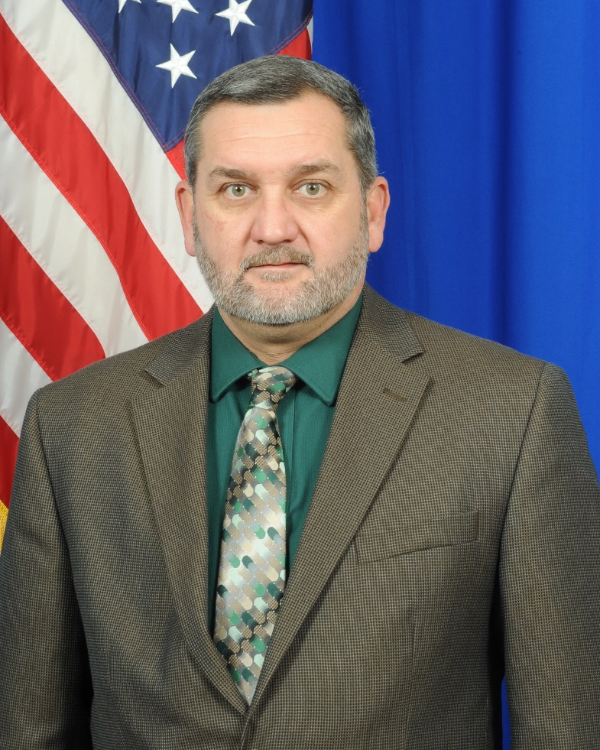
Chief, Division of Reintegration and Outreach

Nicholas “Chip” Gilliland enlisted in the United States Army in 1986. He completed Basic Training at Ft. Dix, NJ and Advanced Individual Training at Ft. Eustis, VA. He was then assigned to B Company, 159th Aviation at Ft. Campbell, KY. In 1988, he was reassigned to B Co, 7/101st Aviation Regiment, 101st Airborne Division, and later deployed to Central America spending 5-1/2 months in Honduras.
Chip left Active Duty and spent the next 18 months in the Individual Ready Reserve. In January of 1991, he was called back to Active Duty to support Operation Desert Shield/Desert Storm, and spent 10 months at Fort Rucker, assigned to F Company, 1st /14th Aviation Training Regiment. He then returned to the Individual Ready Reserve for 18 months. Chip joined the Pennsylvania Army National Guard in 1994, and was assigned to Company G, 104th Aviation. He served in Company G until May of 1996 when he was hired as a CH-47 instructor at the Eastern Army National Guard Aviation Training Site. At the Eastern AATS he has served as an Instructor, Enlisted Standardization Flight Instructor, Senior Instructor, Section Sergeant, Platoon Sergeant, First Sergeant, culminating as the Commandant/Command Sergeant Major.
In November 2009, Chip was selected as the State Command Sergeant Major/Senior Enlisted Leader, Pennsylvania National Guard and served in that position until May 2012. In May of 2012, Chip resigned as the State Command Sergeant Major to serve as the Senior Noncommissioned Officer, B Company 2-104th Aviation, Task Force Nomad, for a 17 month train up and deployment to Afghanistan. Upon returning from his deployment, Chip was assigned to the State Army Aviation Office as the Senior Aviation Sergeant Major until his retirement in December 2013.
Chip was appointed in December 2013 to serve as Chief, Division of Reintegration and Outreach, Pennsylvania Department of Veterans Affairs. Chip currently resides in Palmyra, Pennsylvania with his wife Tracie; they have a son Colby, his wife Stephanie, and granddaughter Briar.

